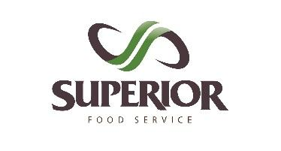

18 Medulla Avenue Etobicoke ON M8Z 5L5 416-646-0207

PAYMENT AUTHORIZATION FORM

WE ACCEPT VISA/MASTERCARD OR E-TRANSFER

Attention: Accounts Receivable

Customer Name: _______________________________________

Cell Phone Number: _______________________________________

Type of Payment: VISA MASTERCARD E-Transfer

________________________________________________________________

For Credit Card Payments

Name on Card: _______________________________________

Card Number: _______________________________________

Expiry Date: _______________________________________

CVD Number: _______________________________________

Cardholder Address: _______________________________________

For E-transfer Payments

Please transfer to the following email: sales@superiorfoodservice.ca

This is to authorize the payment and credit card use, for the purchase of goods from Superior Food Service.

Superior Food Service will only keep this letter on file.

________________________________________
CARDHOLDER INITIALS

